Introduction: it is possible to change a valuation class in a material if
- There is (are) no open Purchase Order(s) or Scheduling Agreement(s) related to the material
- There is (are) no open Sales Order(s) or Scheduling Agreement(s) related to the material
- There is (are) no open Production Order(s) related to the material
- Stock of this material is zero for previous and current logistic period

- Check if there is(are) open Purchase Order(s) (=unmatched Good Receipt or Invoice Receipt)
Transaction ME2M with Selection Parameters RECHNUNG, RETOUREN, WE103 and WE161
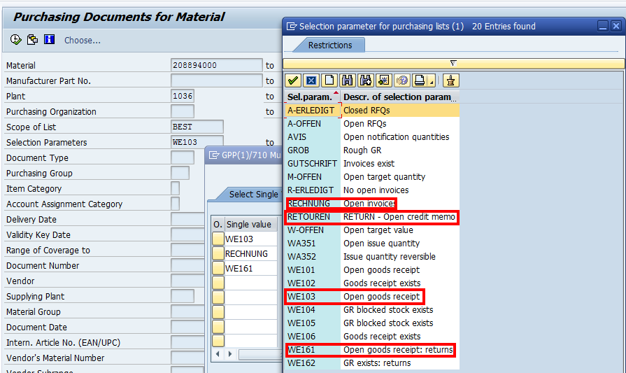

NB1: it is better to put a deletion flag on the closed PO to avoid having Good Receipts or Invoice Receipts posted after the change of the valuation class

NB2: if there is an existing PO without Good Receipt or Invoice Receipt then:
- If it is a stock PO then there is need to change anything
- If it is not a non-stock PO (= assigned to a CO object), then you have to change the GL account in the Account Assignment tab
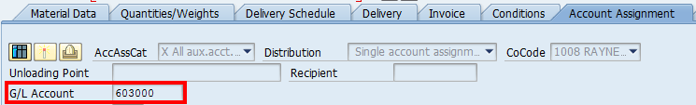

- Check if there is (are) no open Sales Order(s) or Scheduling Agreement(s) related to the material
Use VA05 or VA06 or VA35

- Check if there is (are) open Production Order(s)
Transaction COOIS

Main statuses of Production Orders are:
Created: CRTD
Released: REL
Partially confirmed: PCNF
Totally confirmed: CNF
Partially delivered: PDLV
Totally delivered: DLV
Technically closed: TECO
Deletion indicator: DLT
Deletion flag: DLFL

Normally status should be DLT or DLFL at least but technically SAP allows the modification of the valuation class from TECO status
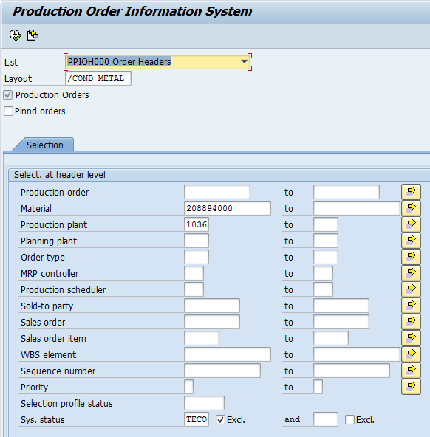

If the production order is linked to a sales order, then the sales order must also have a sufficient status.
PM order status is also a pre-requisite

- Check stock quantity at the end for current period and for last period

Either to go directly in the material master
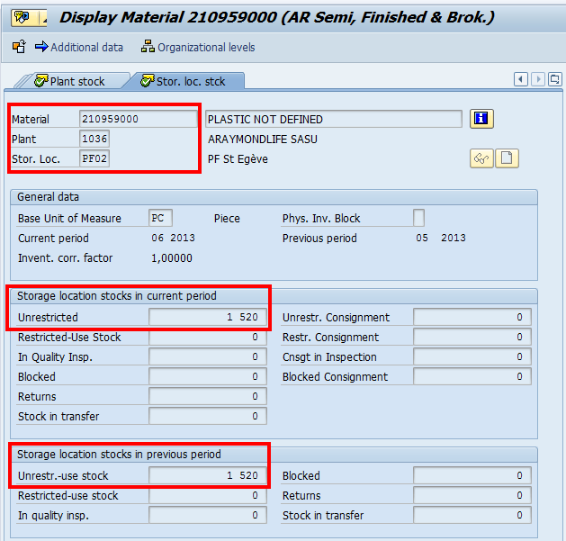

Either to use MCBE, MC.1, MB52, MMBE

- When stock does not equal 0 in the 2 periods when different situation can happen

4.1) Stock in current period = Q1; stock in previous period = 0
➔ MB1C in current period with movement type 562: stock issue (here with a supplier special stock)
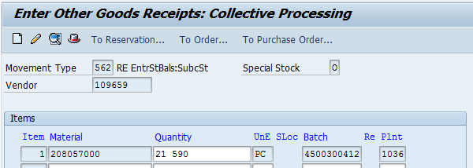

Posting of the stock issue :
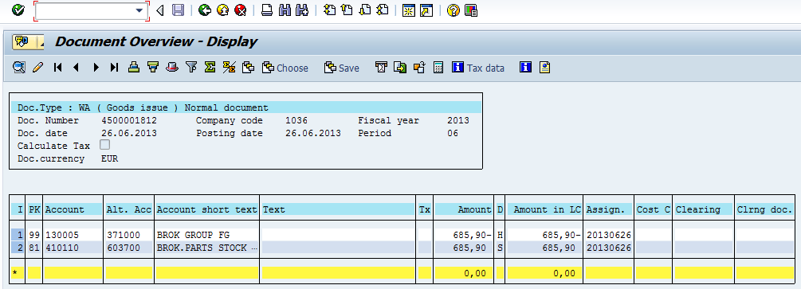

➔ MM02: Change the valuation class in the material. It is possible that SAP sends this warning but it is because closed Purchas Orders do not have a deletion flag. You can ignore it. SAP would block you if it was a blocking cause (like existing stock)
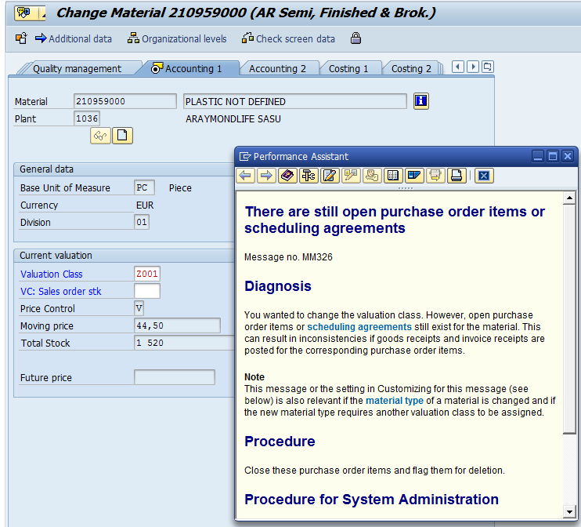

➔MB1C in current period with movement type 561: stock entry (here with a supplier special stock)
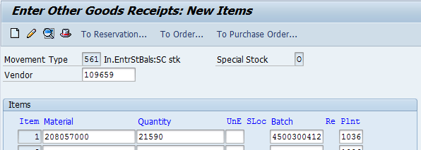

Posting of the stock entry:
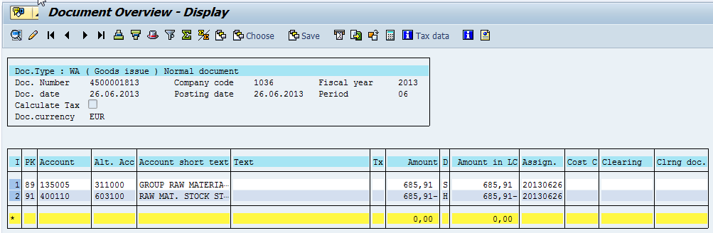

4.2) Stock in current period = 0; stock in previous period = Q2
➔ MB1C in current period with movement type 561 for Q2 quantity: stock entry
➔ MB1C in previous period with movement type 562 for Q2 quantity: stock issue
➔ MM02: Change the valuation class in the material. It is possible that SAP sends this warning but it is because closed Purchas Orders do not have a deletion flag. You can ignore it. SAP would block you if it was a blocking cause (like existing stock)
➔ Reverse the 2 movements using MB1C

4.3) Stock in current period = Q1; stock in previous period = Q2 and Q1 = Q2
➔ MB1C in previous period with movement type 562: stock issue
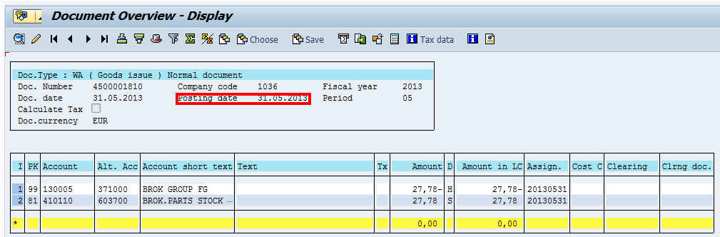
➔ MM02: Change the valuation class in the material. It is possible that SAP sends this warning but it is because closed Purchas Orders do not have a deletion flag. You can ignore it. SAP would block you if it was a blocking cause (like existing stock)
➔ MB1C in current period with movement type 561: stock entry
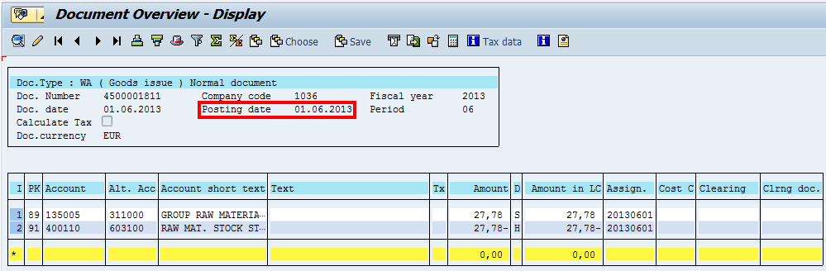
SAP does not let you make the stock entry in the previous period. Therefore it is recommended not to do it at year end closing date

4.4) Stock in current period = Q1; stock in previous period = Q2 and Q1 < Q2
➔ Idem 4.2 but with the difference Q2-Q1

4.5) Stock in current period = Q1; stock in previous period = Q2 and Q1 > Q2
➔ MB1C in previous period with movement type 562 for Q2 quantity: stock issue
➔ MB1C in current period with movement type 562 for Q1-Q2 quantity: stock issue
➔ MM02: Change the valuation class in the material. It is possible that SAP sends this warning but it is because closed Purchas Orders do not have a deletion flag. You can ignore it. SAP would block you if it was a blocking cause (like existing stock)
➔ Reverse the 2 movements using MB1C

